http://windows.microsoft.com/en-US/windows7/Include-folders-in-a-library

To include a network folder in a library
A network folder must be added to the index or made available offline before it can be included in a library. To learn how to make a network folder available offline, see Libraries: frequently asked questions.
======== how to make a network folder available offline ===================

http://windows.microsoft.com/en-US/windows7/Libraries-frequently-asked-questions

What types of locations are supported in libraries?
You can include folders in a library from many different locations, such as your computer's C drive, an external hard drive, or a network.
Where is the folder stored? | Can it be included in a library?
On your C drive | Yes.
On an external hard drive | Yes, but the content won't be available if the drive is disconnected.
On an additional hard disk inside your computer | Yes.
On a USB flash drive | Only if the device appears in the navigation pane, under Computer, in the Hard Disk Drives section. This is set by the device manufacturer, and in some cases, it can be changed. Contact your manufacturer for more information.  The content won't be available if the drive is disconnected.
On removable media (such as a CD or DVD) | No.
On a network | Yes, as long as the network location is indexed, or the folder has been made available offline. (See the question below.)
On a different computer in your homegroup | Yes. For more information, search Windows Help and Support for "Add computers to a homegroup."

Note
Only folders can be included in libraries. Other items on your computer (such as saved searches and search connectors) can't be included.

Why did I get a message saying that a location can't be included because it's not indexed?
It means that the folder is stored on a network location that hasn't been indexed. A network folder can only be included in a library if the content of the folder has been added to the search index. If the folder is already indexed on the device where it's stored, you should be able to include it directly in the library.
If the network folder is not indexed, an easy way to index it is to make the folder available offline. This will create offline versions of the files in the folder and add these files to the search index on your computer. After you make a folder available offline, you can include it in a library.
When you make a network folder available offline, copies of all the files in that folder will be stored on your computer's hard disk. Take this into consideration if the network folder contains a large number of files.

To make a folder available offline
- While connected to the network, locate the network folder that you want to make available offline.
- Right-click the folder, and then click Always available offline.
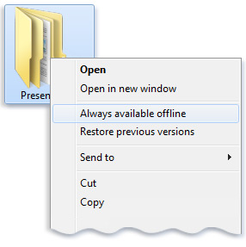The Always available offline command

Notes
- If you don't see the Always available offline command in the right-click menu for a network folder, you might be using an edition of Windows 7 that doesn't support offline files.
- If the network folder you're trying to include is stored on a computer that's running an older version of Windows, you might be able to make it compatible with Windows 7 libraries by installing Windows Search 4.0 on the computer, and then indexing it. For more information about Windows Search 4.0, see the Windows Search website.

- In the taskbar, click the Windows Explorer button .
- Do one of the following:
  - In the navigation pane (the left pane), click Network, and then navigate to the folder on your network that you want to include.
  - Click the icon on the left side of the address bar, type the path of the network, press Enter, and then navigate to the folder that you want to include.
- In the toolbar (above the file list), click Include in library, and then click a library (for example, Documents).

Note
If you don't see the Include in library option, it means that the network folder is not indexed or is not available offline.
======================================
http://www.sevenforums.com/tutorials/4617-libraries-include-network-folder.html
How to Include a Network Drive or Folder in a Library in Windows 7

Information
By default, Windows 7 does not allow you to include network drives or folders in a library. This is because folders must be indexed first in order to be added to a library, and network drives cannot be indexed unless they are synchronized. This will show you how to do that and add them to a library.
Tip
The full path to the hidden Libraries folder is below.
C:\Users\(User-Name)\AppData\Roaming\Microsoft\Windows\Libraries
OR
%AppData%\Microsoft\Windows\Libraries

METHOD ONE

Synchronize the Network Folder or Drive
WARNING: The disadvantage of this method is that it actually copies (syncs) all network files locally so that they are available offline. It actually makes networking useless since you have to bring everything on your PC. For those not interested for this approach, please use method 2.
1. Right click on the network folder or network drive you wish to include to a library (or create a new one for it) and select "Always Available Offline". A synching process will start, synchronizing your network folder.
2. Now you can add it to a library.

METHOD TWO

Using mklink Command
1. Create a temp folder on your hard drive i.e. c:\shares
2. Create another folder in the above folder. i.e. c:\shares\pictures
3. Link the Library to this folder.
4. Delete the folder (c:\shares\pictures).
5. Use the mklink in an elevated command prompt to make a symbolic link. Name the link the same as the folder you created above. i.e -
mklink /d c:\shares\pictures \\server\pictures
6. Done. Now you have a non-indexed network path as a library.
Related Tutorials

- How to Hide or Show a Library in the Windows 7 Navigation Pane
- How to Restore the Default Libraries in Windows 7
- How to Fix Libraries when Hidden and Empty in Windows 7
- How to Create a New Library in Windows 7
- How to Include a Folder in a Library in Windows 7
- How to Include a Network Drive or Folder in a Library in Windows 7
- How to Remove a Included Folder from a Library in Windows 7
- How to Set the Default Save Folder for a Library in Windows 7
- User Folders in Windows 7 Libraries
- How to Turn the Library Pane On or Off in Windows 7
- How to Add or Remove "Include in library" in Windows 7 Context Menu

Windows 7 - Offline Files - Make Files or Folders Available Offline
Recommended Fix: Click here to fix Windows 7 errors and optimize system Performance
http://www.sevenforums.com/tutorials/783-elevated-command-prompt.html?ltr=E
How to Open a Elevated Command Prompt in Windows 7

Information
This will show you how to open a elevated command prompt with administrator rights (Run as administrator) instead of the default command prompt without administrator rights in Windows 7.
Tip
If you opened the elevated command prompt from a shortcut (ex: in Start Menu) and it opens to another location other than C:\Windows\System32, then right click on the shortcut and click on Properties. In the Shortcut tab, check to make sure that you have %HOMEDRIVE%%HOMEPATH% in the Start in field like below.
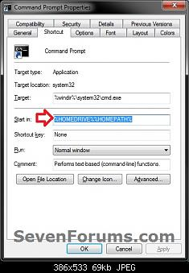
EXAMPLE: Elevated Command Prompt
NOTE: Notice how the elevated command prompt opens to C:\Windows\System32 and not C:\Users\(user name) as the default command prompt without administrator rights.
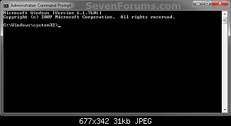
Here's How:
1. Use a Elevated Command Prompt shortcut.
OR
2. Open the Start Menu.
3. Click on All Programs and Accessories, then right click on Command Prompt and click on Run as administrator. (see screenshot below)
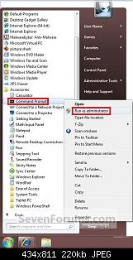
OR
4. Open the Start Menu.
5. In the Start Menu search box area, type cmd and press CTRL+SHIFT+ENTER.
OR
6. Open the Start Menu.
7. In the Start Menu search box area type cmd, then right click on cmd.exe (at top), and click on Run as administrator. (see screenshot below)
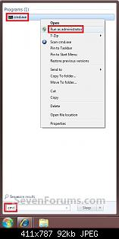
Tip
- If you are in a administrator account and get a log in prompt after doing any of the above steps, then click on the Cancel button and repeat the above step again. This will only do this for the very first time you try to open a elevated command prompt in Windows 7.
- If you are in a standard account, then you will need to type in the administrator's password to elevate the command prompt.
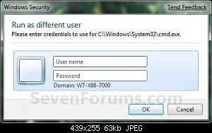

http://www.sevenforums.com/tutorials/48852-offline-files-make-files-folders-available-offline.html

Offline Files - Make Files or Folders Available Offline
How to Make Network Files or Folders Available Offline in Windows 7
Published by Brink
12-23-2009
Offline Files - Make Files or Folders Available Offline

How to Make Network Files or Folders Available Offline in Windows 7

Information
If you work with files on a network, you can make the files available offline so you can access them even when your computer is not connected to the network. This is especially useful if you use a laptop to connect to a workplace network.
When you make a network file, or all files in a network folder, available offline, Windows creates a copy of the file or folder on your computer. This is called an offline file. The next time you disconnect from the network, you'll still be able to open, modify, and save the file the same way you would if you were still connected. And when you do connect to the network again, Windows will automatically sync the offline file on your computer with the corresponding file on the network to update it.
This will show you how to make a network file or folder to be Always available offline or not.
Note
- Offline files is enabled by default in the Windows 7 Professional, Ultimate, and Enterprise editions.
- Offline files is not available in the Windows 7 Starter, Home Basic, and Home Premium editions.
Here's How:
1. If you have not already, you will need to have the use of Offline files enabled before you can make a network file or folder to be Always available offline.
2. While connected to the network, browse to the network file or folder location that you want to make available offline.
NOTE: These will usually be located in your Network group in the Windows Explorer Navigation Pane, or the Network button in the Start Menu.
3. To Make the Network File or Folder Always Available Offline
A) Right click on the network folder or file (in a network folder), and click on Always available offline to check it. (see screenshot below)
B) Go to step 5.
4. To Make the Network File or Folder NOT Always Available Offline Anymore
A) Right click on the network folder or file (in a network folder), and click on Always available offline to uncheck it. (see screenshot below)
5. You will now see this for a brief moment while the network file or folder is being made or not made always available offline. (see screenshots below)
6. You will now notice that the network file or folder icon with have the Sync overlay icon on it if made always available offline, and no longer there if made not always available offline anymore. (see screenshot below)

http://www.pcworld.com/article/186433/add_network_folders_to_windows_7_libraries.html

Add Network Folders to Windows 7 Libraries
By Rick Broida, PCWorld Jan 8, 2010 3:54 PM
I'm a big fan of Windows 7's Libraries feature, which makes it easy to find the documents, music, pictures, and videos scattered across various locations on your hard drive.
Just one problem: Libraries don't support network locations. That's a pretty huge hassle for anyone who has multiple PCs, as sometimes the files you want are sitting on another hard drive.
Enter Win7 Library Tool, a handy little utility that makes it easy to add network folders to your Libraries. So, for example, if I want to view the digital photos on my wife's PC, I can now add her Photos folder to my Pictures Library. Awesome.
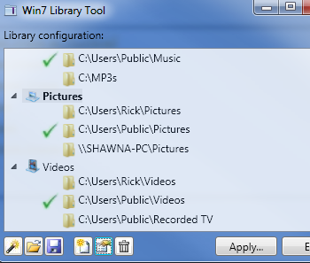
Just as handy, the tool provides a centralized location for tweaking your Library settings. It even lets you change the icons for various Libraries. But I think my favorite Win7 Library Tool feature is backups: You can save a set of libraries for later restoration, like after you've done an OS reinstall or migrated to a new PC.
Suffice it to say, this is a must-have app for anyone who spends a lot of time at the "Library." And I'm happy to report it's free.
(Need a Libraries primer? My colleague Dave Johnson, of PC World Digital Focus fame, recently produced a video showing how Libraries make searches more effective.)
- See more like this:
- Windows 7,
- file management,
- utilities
http://abendin.hubpages.com/hub/Adding-a-Network-Directory-to-a-Library-without-Indexing-in-Windows-7

Windows 7: Adding a Network Directory to a Library without Indexing
Windows 7 introduces Libraries to the PC user, a feature intended to help organize files from the point they are saved. Though powerful when used properly, this feature does have it's limitations and drawbacks, one major one being the difficulty of including network directories in these libraries.
What are Libraries?
The users of many multimedia programs such as iTunes will be familiar with the library format. Basically, it is a virtual folder that contains links to other directories that house the types of files you are looking to organize. Windows 7 takes this concept a step further by applying it to the operating system as a whole, allowing the Documents library to link to various other directories on the local system. Also included are Music, Picture, and Video libraries to do the same.
Any folder on the local hard drive can be added to these libraries to help centralize file access. Though the files will still be stored in their directories on the drive, they can be accessed from the libraries easily.
In many corporate and home networks, you may store files on servers or other networked locations. When trying to add these locations into a library, Windows 7 will tell you that the drive must be indexed and made available offline in order to be added. Depending on the size and amount of files in the network location, this can take a substantial amount of time, and also poses a security risk as the network location must be available offline. It will also eat up valuable disk space as a local copy must be downloaded to the PC.
We will explore a workaround to this problem in this article.
Adding a Network Directory to a Library
To add a network location to a library, use a symlink to point to the network folder location:
- Create a local folder in the C:\Users\username\ directory. This can be named anything you want, so long as it is a valid directory name.
- Add that folder into the library. Open the library from the menu bar, then click on the Includes: # locations link at the top. Click the Add button on the right side and select the folder you just created.
- Delete the local folder that you created. DO NOT remove it from the library.
- Start a Command Prompt (Start->Run, type CMD and press Enter).
- Type the following command: MKLINK /D "LINK" "TARGET". Replace LINK and TARGET with the path of the folder that was just deleted and the path of the network location you wish to add to the library, respectively. For a full explanation of the MKLINK command, type MKLINK /? and hit enter.
If you browse to the C:\Users\Username\ directory, you will now see a symbolic link (symlink) with the same name as the folder that was previously deleted. Exploring this will lead you to the network location that was entered as the target. Open the library, and you should see the network location as a location. Any changes made to the folder in the library will reflect automatically in the network location, and vice versa.
Congratulations, you've just added a network drive to a library without indexing it!

